**USER MANUAL**

**(MIS- Nodal Marks Approve/Reject)**

**STEP – 1:-** Open NCVT public portal site using the URL, <https://ncvtmis.gov.in/pages/home.aspx>

**STEP – 2: -** Click the **Login** Link on page

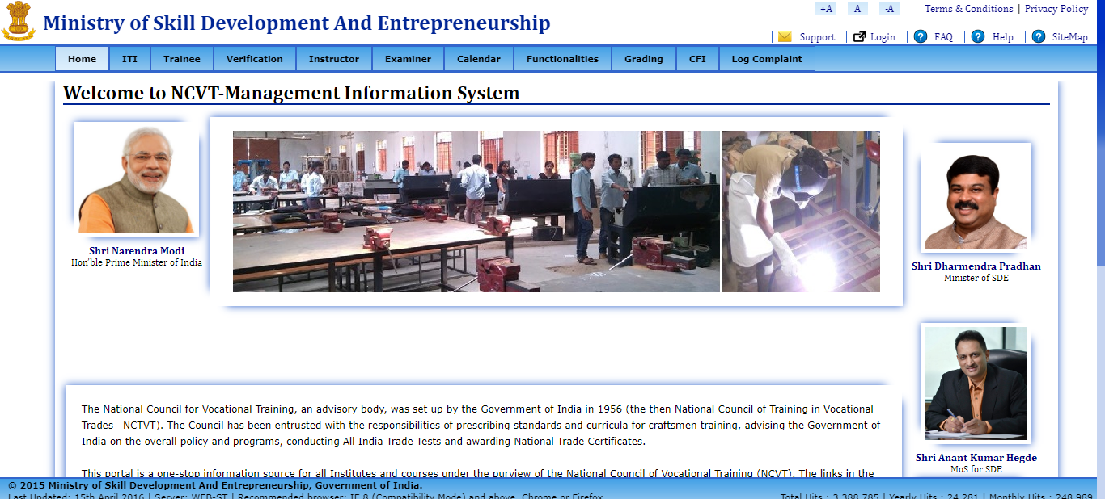

**STEP – 3**: - Login with SPIU credentials.

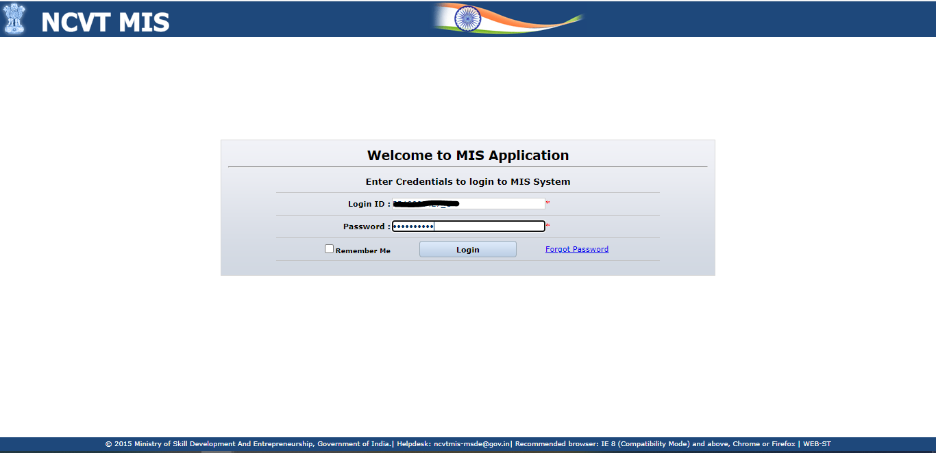

**STEP-4:-** Navigate to the below path: **-**

**Menu🡪 ITI🡪 Examination Management 🡪Trainee Marks 🡪 Nodal Marks Approve/ reject**

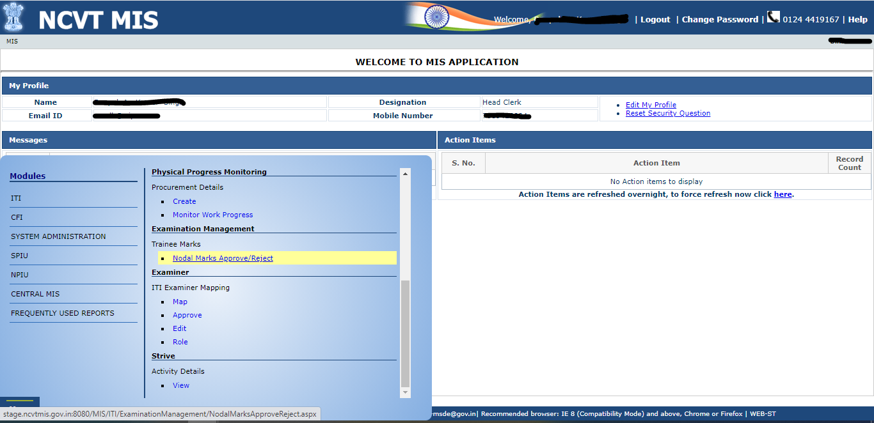

**STEP-5:-** On Clicking Create ED Marks, A new page will open where user can create trainee semester/ Annual Marks.

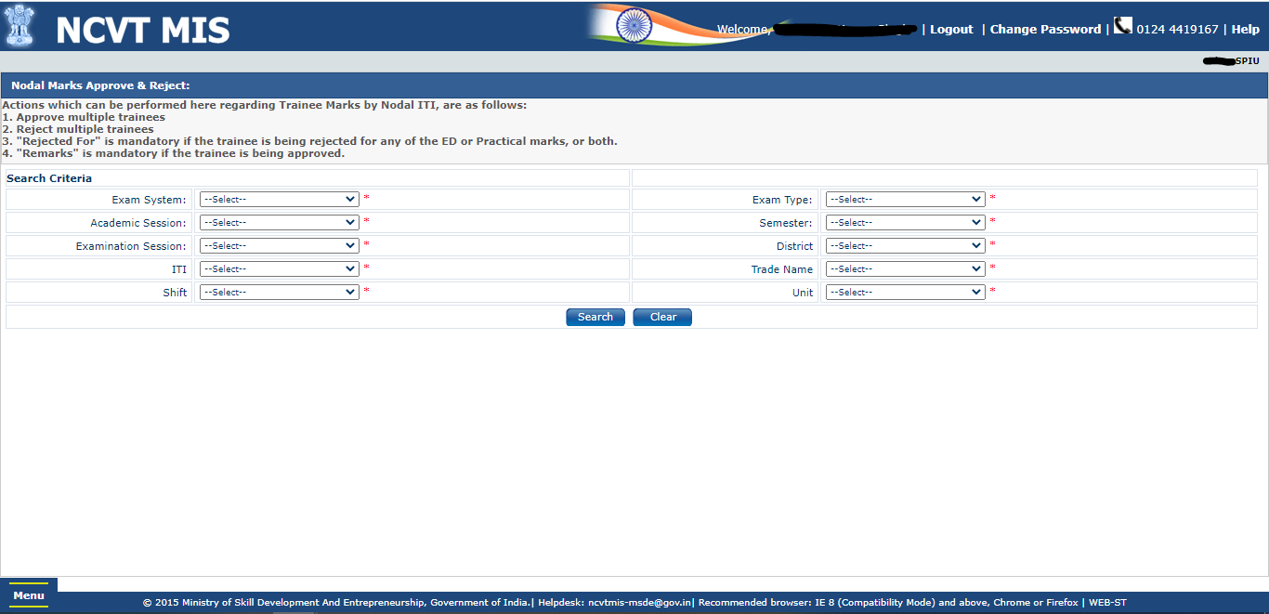

**NOTE: In Search Criteria all the fields are mandatory, Please fill all the Fields without miss otherwise it will show you error.**

**STEP-6:-** After selecting all the fields in search Criteria, on click of search, the list of trainees whose data will be shown whose marks will be either Approve/ Reject by user.

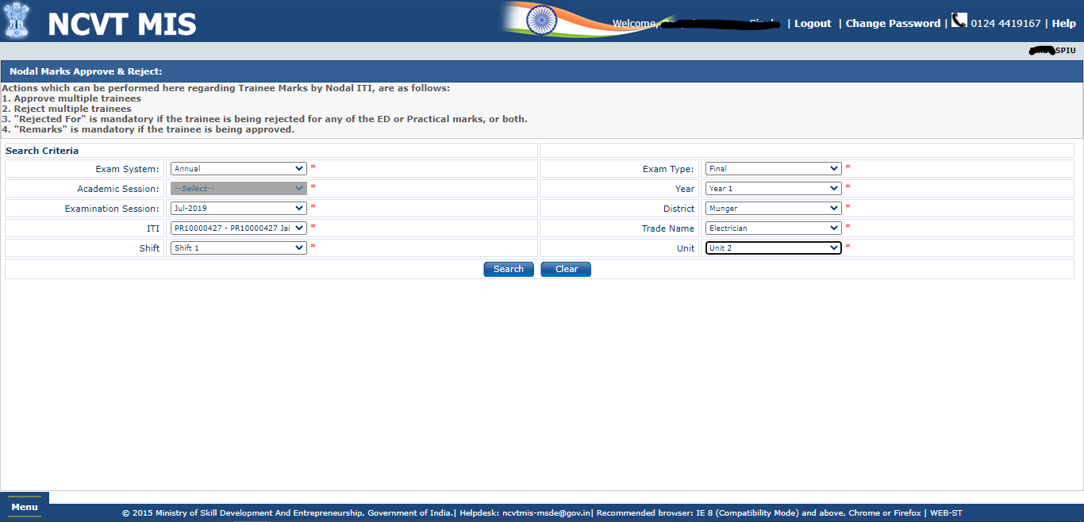

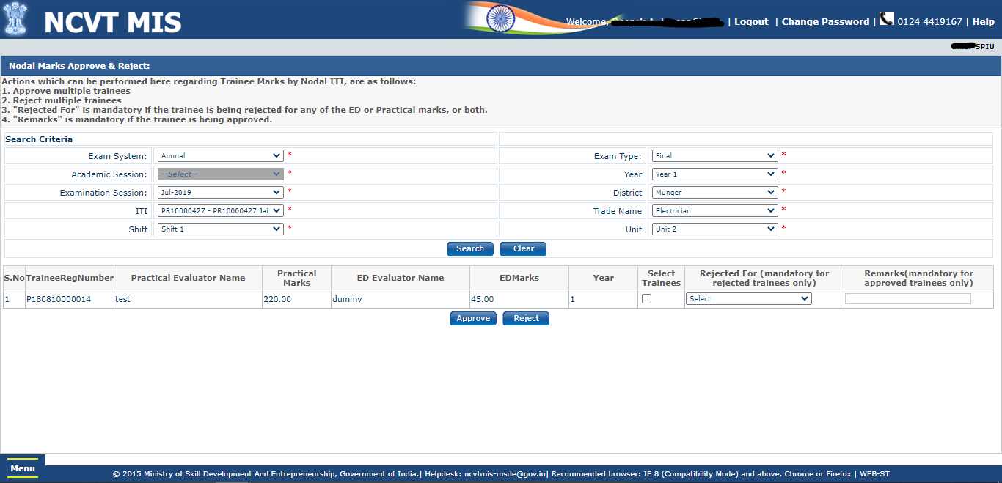

**STEP-7:-** On Rejected, there are 3 options which can selected: -

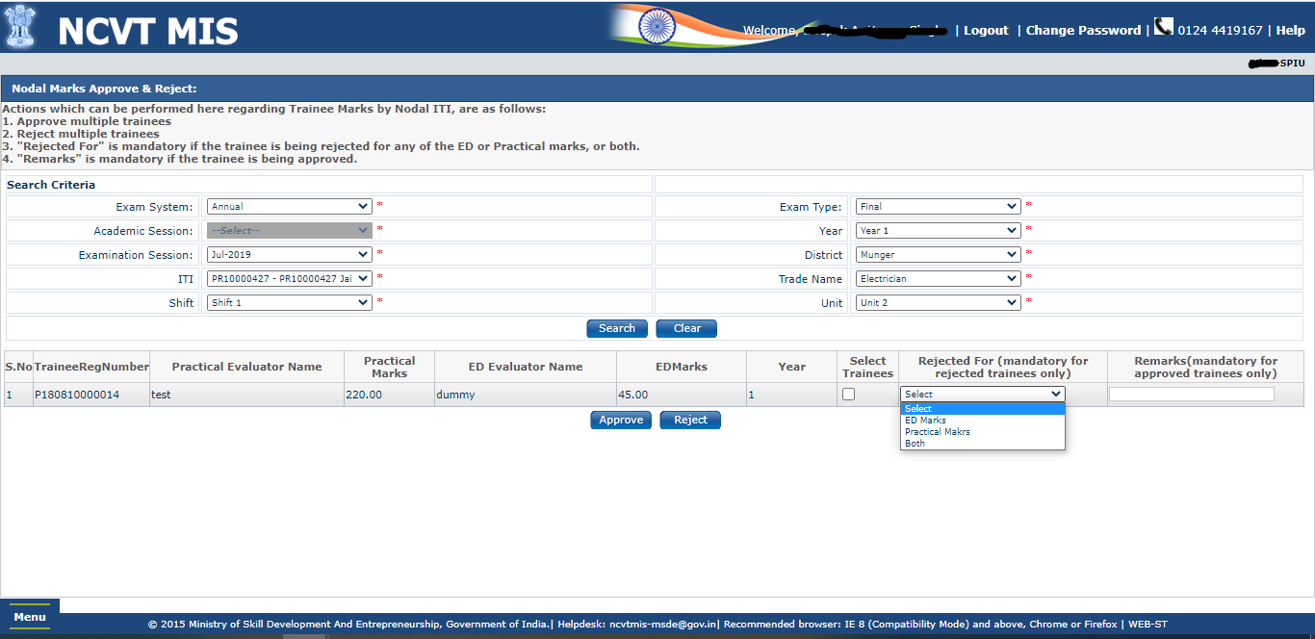

1. Rejected for ED Marks: here user can reject the data if user finds only ED marks are Not valid.

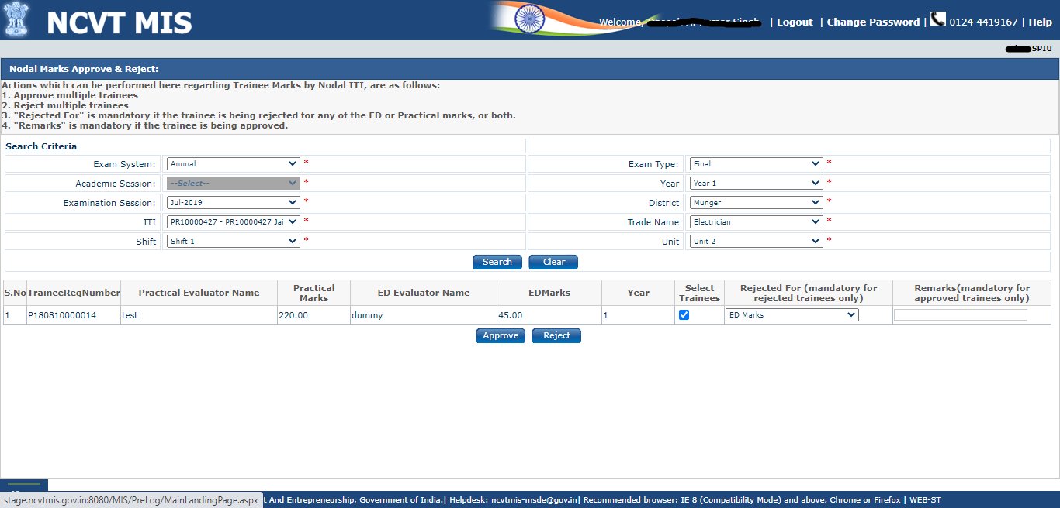

1. Rejected for Practical Marks: here user can reject the data if user finds only Practical marks are Not valid.

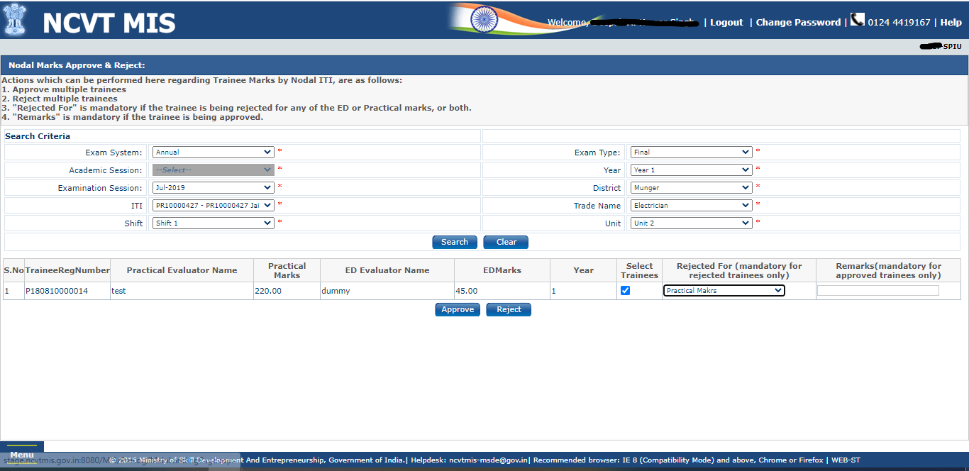

1. Rejected for Both: here user can reject the data if user finds both ED and Practical Marks are Not valid.

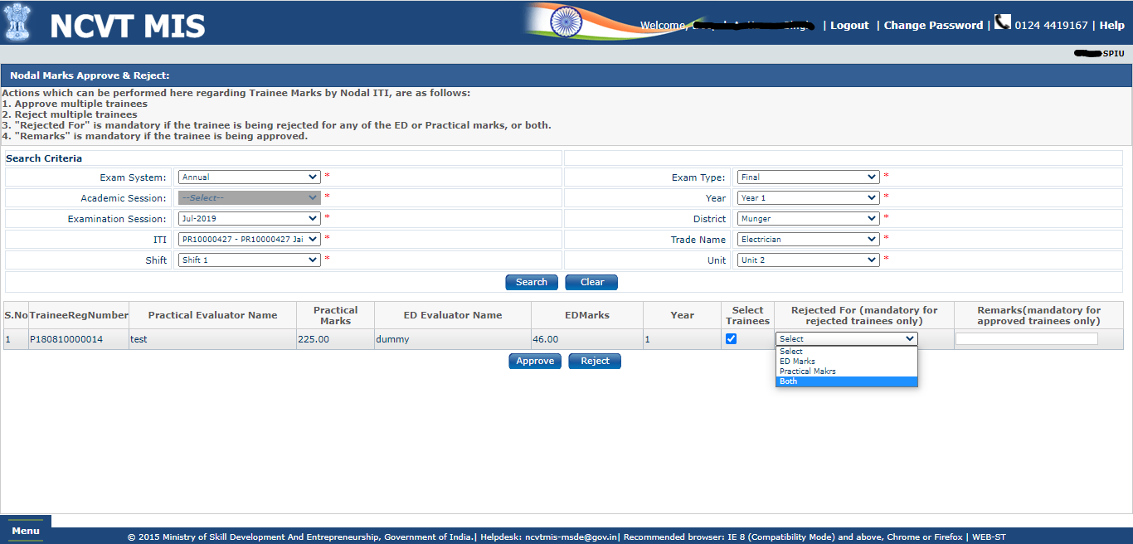

NOTE:- Now select any of the option from the drop down and click on submit your selected data will be rejected successfully.

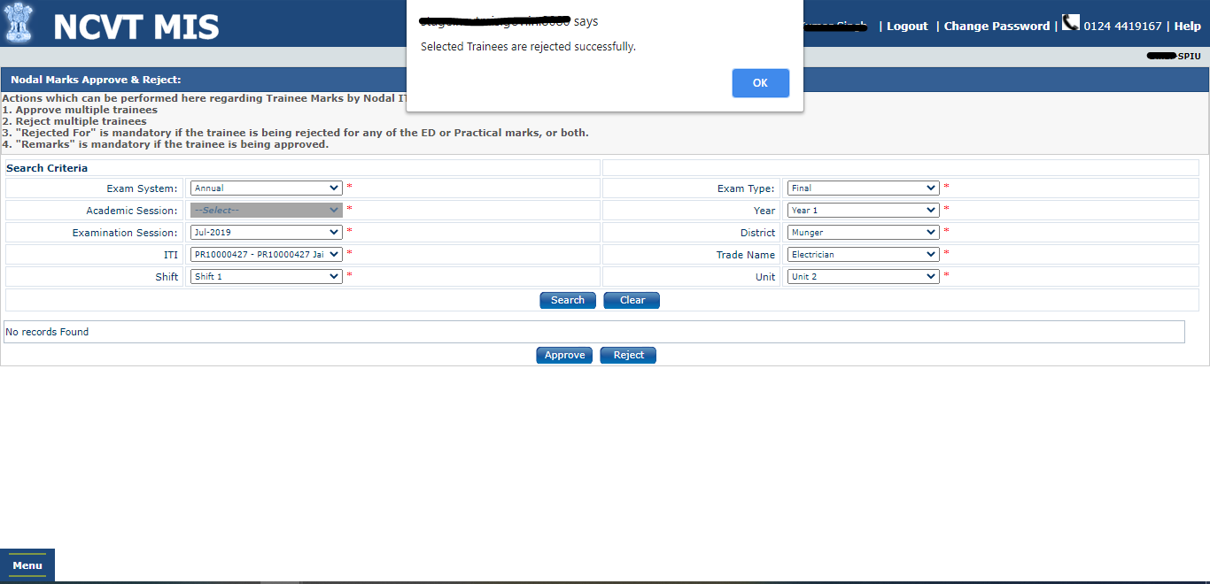

**STEP-8:-** For Approve, Just mention the reamrks and select the record and click on submit, data will be submitted successfully.

